

**FACULTY OF INFORMATION AND COMMUNICATION TECHNOLOGIES**

**FALL 2023**

**CA EXAMINATION**

NAME: NDE HURICH DILAN

MATRICULE:ICTU20223351

EMAIL: nde.dilan@ictuniversity.edu.cm

TEL:+237694525931

**CCNA CA**

1-configure router1 with the hostname R1

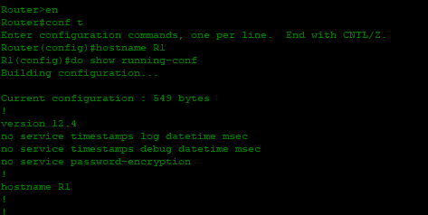

2-configure router 2 with the hostname R2

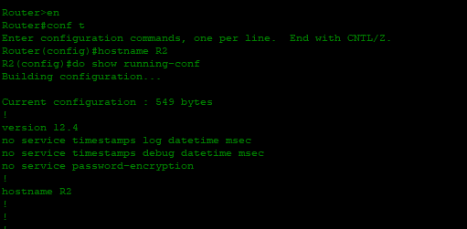

3-Configure switch with the hostname SW1

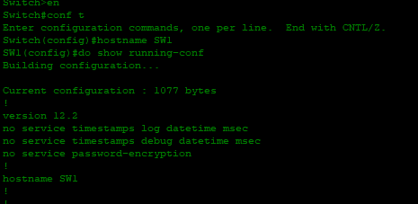

The same command again for the last one

4-Configure the ip address of R1 according to the topology on the figure

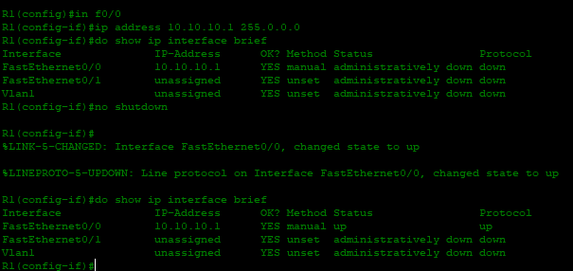

5-Configure the ip address of R2 according to the topology on the figure

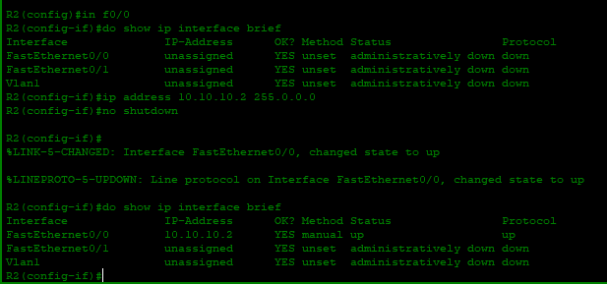

6-Give SW1 the management IP address 10.10.10.10/24:

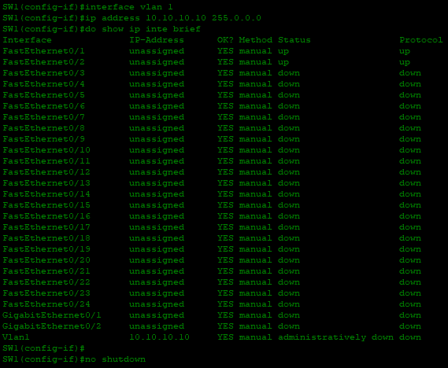

7-The switch should have connectivity to other IP subnets via R2:



8-Verify that the switch can ping its default gateway:

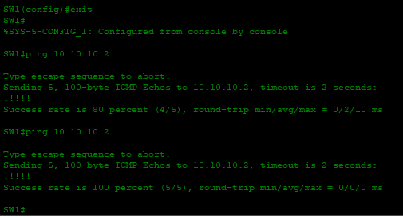

It failed the first time so I tried again

9-Configure suitable descriptions for the connected devices

Let’s see configure one by one

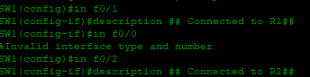   


Let’s see those descriptions

10-Verify that the link to R1 is on a full duplex mode and that the speed is set to 100Mbs

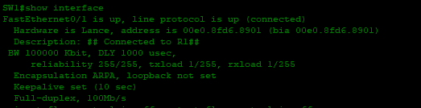

From here we can see the duplex and speed settings for f0/1 which is linked to R1

11-Manually configure full duplex and FastEthernet speed on the link to R2:

After everything is don ewe can check the results

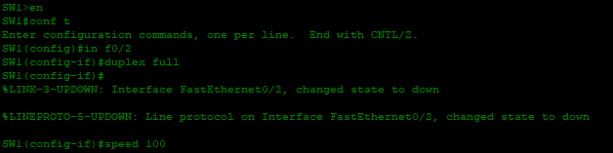



12-Which version of IOS is you Cisco device using?

It seems like it’s version 12.2



13-Verify the directly attached Cisco neighbors using Cisco Discovery Protocol (CDP):

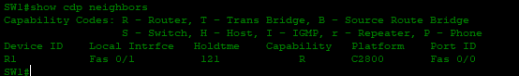

14-Prevent R1 from accessing information on SW1 via CDP

Let’s disable Cisco discovery protocol on the link between R2 and SW1



15-Flush the CDP cache on R1:

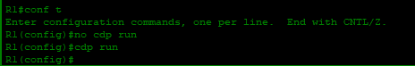

As shown below SW1 is no longer there.

16-Verify that R1 cannot see SW1 via CDP:

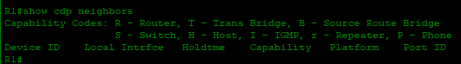

17-Let’s verify the status of the switch port connected to R2 with the **show ip interface brief** command.

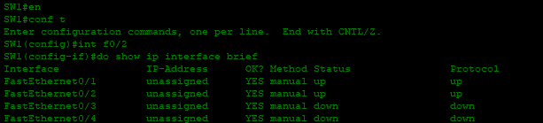

18-Shut down the interface connected to R2 and issue a show ip interface brief command again.

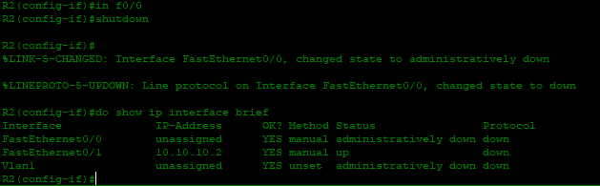

19) Bring the interface up again:

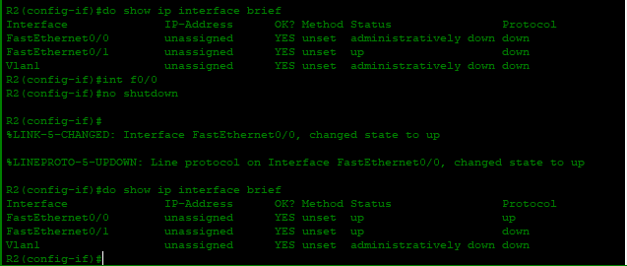

20) and 21) Set the duplex to half on Switch 1 and verify the state of the interface:

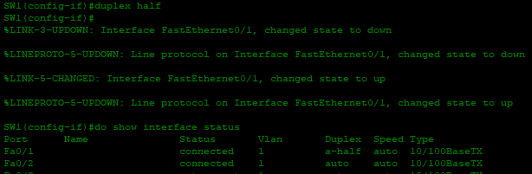

22-23) Set the duplex back to full duplex and set the speed to 10 Mbps:

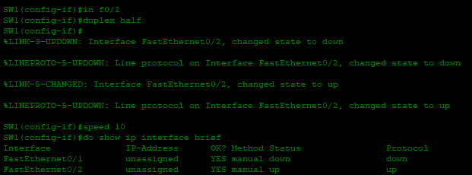

24)Check if the interface is still operational:



25)Check if the interface is operational on R2



The status is up/up

**SLIDE 14 QUESTION 1-5**

1-You have been given the 172.30.0.0/16 network. Your company requires 100 subnets with at least 500 hosts per subnet. What prefix length should you use?

To find the prefix length we should use, let’s find the number of borrowed bits.

We know that $2^{x}=number of subnets$ where x is the number of borrowed bits. So, we have $2^{x}=100 then x=\frac{\ln\left(100\right)}{\ln\left(2\right)} which give us x≈7$

$$so we need to borrow 7 bits and we will have 128$$

$$subnets which are more than sufficient and the$$

$$number of host is 2^{9}-2 which is 510 host$$

And since we borrow 7bits, we will have a prefix length of 16+7=23.

2-What subnet does host 172.21.111.201/20 belong to?

To find the subnet it belongs to, we just need to find the network address of that subnet and to do that we can convert everything to binary and we will have :

1 0 1 0 1 1 0 0 . 0 0 0 1 0 1 0 1 . 0 1 1 0 1 1 1 1 . 1 1 0 0 1 0 0 1 since it’s a /20 it means that we have borrowed 4 bits so the last 12 bits are for the host, let’s make them all 0

1 0 1 0 1 1 0 0 . 0 0 0 1 0 1 0 1 . 0 1 1 0 0 0 0 0 . 0 0 0 0 0 0 0 0

Now if we convert it back, we will have 172 . 21 . 96 . 0 Which is what we are looking for. **So, the subnet mask is 172 . 21 . 96 .0**

3-What is the broadcast address of the network 192.168.91.78/26 belongs to?

It’s the same process as the last one but instead of turning all the host bits to **0** we will turn them into **1**.

So, we have 1 1 0 0 0 0 0 0 . 1 0 1 0 1 0 0 0 . 0 1 0 1 1 0 1 1 . 0 1 0 0 1 1 1 0 and then

1 1 0 0 0 0 0 0 . 1 0 1 0 1 0 0 0 . 0 1 0 1 1 0 1 1 . 0 1 1 1 1 1 1 1 (note that the number of borrowed bits was 2)

**Converting it back to decimal give us 192.168.91.127/26**

4- You divide the 172.16.0.0/16 network into 4 subnets of equal size. Identify the network and broadcast addresses of the second subnet

To complete the task, we need to find the network address of the first network and then deduce.

First, we know that they are 4 subnets so 2 bits were borrowed, converting the address into binary give us : **1 0 1 0 1 1 0 0 . 0 0 0 1 0 0 0 0 . 0 0 0 0 0 0 0 0 0 . 0 0 0 0 0 0 0 0 (1st network address)**

to have the second network address we just add a 64 after 172.16 and in binary we get : **1 0 1 0 1 1 0 0 . 0 0 0 1 0 0 0 0 . 0 1 0 0 0 0 0 0 . 0 0 0 0 0 0 0 0 (2nd network address) In decimal it gives us 172 . 16 . 64 . 0**

From there now we just turn the host part all to 1 to find the broadcast address, so in the end of the day the broadcast address is **1 0 1 0 1 1 0 0 . 0 0 0 1 0 0 0 0 . 0 1 1 1 1 1 1 1 . 1 1 1 1 1 1 1 1**

**which in decimal give 172 . 16 . 127 . 255.**

**So, the** network and broadcast addresses of the second subnet are **172 . 16 . 64 . 0** and **172 . 16 . 127 . 255**

5- You divide the 172.30.0.0/16 network into subnets of 1000 hosts each. How many subnets are you able to make?

We know that we have 1000 hosts and the formula is $2^{n}-2=number of host=>n=\frac{ln⁡(1000+2)}{ln⁡(2)}$

So $n≈10$.

**We have $2^{10}-2=1022 which large enough.$**

**And 64 subnets.**

Study the slide of day 15 and do a summary of it:

The day 15’s document outlines the subnetting process for Class A and Class B networks, with a specific task of creating 2000 subnets for the 10.0.0.0/8 network. The use of a /19 prefix length is recommended for Class B networks, providing 8190 usable host addresses per subnet. Subnetting Class A networks is exemplified through the IP address 10.217.182.223/11, demonstrating the determination of network and broadcast addresses, as well as the range of usable addresses.

A crucial concept introduced is Variable-Length Subnet Masks (VLSM), highlighting its efficiency in optimizing network address utilization. The VLSM implementation process involves assigning the largest subnet first and then proceeding with subsequent subnets.

An illustrative example showcases VLSM in action, dividing subnets for Tokyo LAN A, Tokyo LAN B, Toronto LAN A, and Toronto LAN B. Each subnet's network and broadcast addresses, along with the range of usable addresses, are meticulously calculated. The scenario concludes by emphasizing the effectiveness of VLSM in creating various subnets with different prefix lengths, thereby maximizing the efficient use of address space.

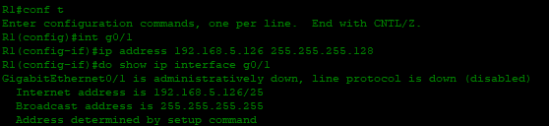

**Summary Of The Implementation**

In this lab focused on Variable Length Subnet Masking (VLSM), the primary objective was to implement VLSM for a given IP address (192.168.5.0/24) to accommodate addressing requirements for various LANs, including the point-to-point network. Determining the first and last usable addresses posed no challenges when the network ID and broadcast ID were readily available.

The more intricate aspect of the exercise involved configuring static routes on each router. Through this, I gained insight into the importance of establishing reachability by configuring the next hop for different routers. The 'ip route' command was instrumental in achieving this configuration, emphasizing the significance of routing in network setups.

